Use this page to track image usage or record descriptions. This document can be adapted for your needs and re-saved.

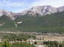 | Alberta Image 1
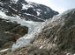 | Alberta Image 2
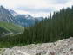 | Alberta Image 3
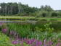 | Alberta Image 4
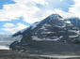 | Alberta Image 5
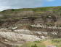 | Alberta Image 6
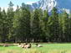 | Alberta Image 7
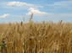 | Alberta Image 8

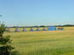 | Alberta Image 9

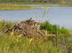 | Alberta Image 10
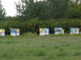 | Alberta Image 11
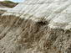 | Alberta Image 12
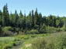 | Alberta Image 13
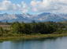 | Alberta Image 14
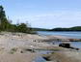 | Alberta Image 15
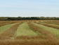 | Alberta Image 16

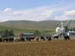 | Alberta Image 17
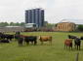 | Alberta Image 18
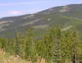 | Alberta Image 19
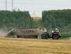 | Alberta Image 20
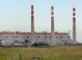 | Alberta Image 21
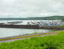 | Alberta Image 22
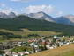 | Alberta Image 23
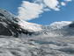 | Alberta Image 24

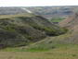 | Alberta Image 25
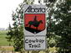 | Alberta Image 26
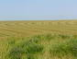 | Alberta Image 27
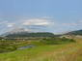 | Alberta Image 28
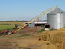 | Alberta Image 29

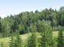 | Alberta Image 30
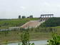 | Alberta Image 31
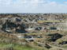 | Alberta Image 32

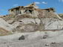 | Alberta Image 33
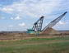 | Alberta Image 34
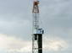 | Alberta Image 35
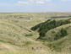 | Alberta Image 36
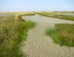 | Alberta Image 37
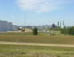 | Alberta Image 38
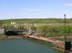 | Alberta Image 39
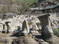 | Alberta Image 40

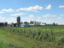 | Alberta Image 41
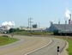 | Alberta Image 42
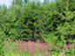 | Alberta Image 43
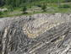 | Alberta Image 44
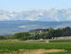 | Alberta Image 45
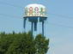 | Alberta Image 46
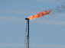 | Alberta Image 47
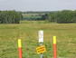 | Alberta Image 48

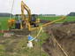 | Alberta Image 49

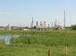 | Alberta Image 50
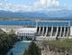 | Alberta Image 51
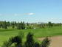 | Alberta Image 52
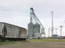 | Alberta Image 53
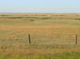 | Alberta Image 54
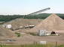 | Alberta Image 55
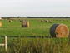 | Alberta Image 56

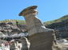 | Alberta Image 57
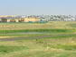 | Alberta Image 58
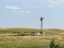 | Alberta Image 59
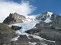 | Alberta Image 60
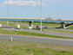 | Alberta Image 61
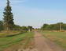 | Alberta Image 62
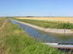 | Alberta Image 63
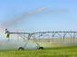 | Alberta Image 64

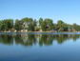 | Alberta Image 65
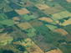 | Alberta Image 66
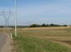 | Alberta Image 67
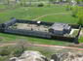 | Alberta Image 68
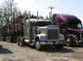 | Alberta Image 69

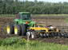 | Alberta Image 70
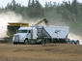 | Alberta Image 71
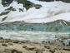 | Alberta Image 72

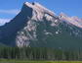 | Alberta Image 73
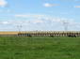 | Alberta Image 74
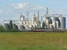 | Alberta Image 75
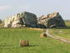 | Alberta Image 76

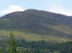 | Alberta Image 77
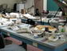 | Alberta Image 78

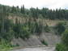 | Alberta Image 79
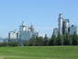 | Alberta Image 80
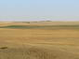 | Alberta Image 81
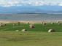 | Alberta Image 82
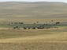 | Alberta Image 83
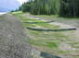 | Alberta Image 84
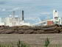 | Alberta Image 85
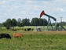 | Alberta Image 86
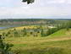 | Alberta Image 87

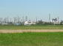 | Alberta Image 88

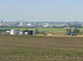 | Alberta Image 89
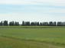 | Alberta Image 90
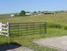 | Alberta Image 91
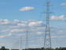 | Alberta Image 92
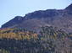 | Alberta Image 93
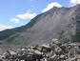 | Alberta Image 94
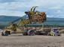 | Alberta Image 95
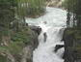 | Alberta Image 96

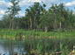 | Alberta Image 97
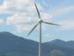 | Alberta Image 98
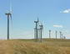 | Alberta Image 99
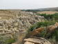 | Alberta Image 100
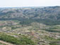 | Alberta Image 101
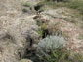 | Alberta Image 102
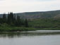 | Alberta Image 103
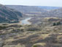 | Alberta Image 104

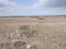 | Alberta Image 105
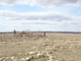 | Alberta Image 106
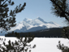 | Alberta Image 107
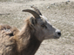 | Alberta Image 108
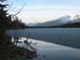 | Alberta Image 109
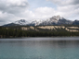 | Alberta Image 110
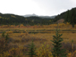 | Alberta Image 111
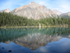 | Alberta Image 112

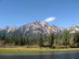 | Alberta Image 113
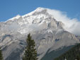 | Alberta Image 114

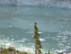 | Alberta Image 115
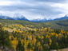 | Alberta Image 116
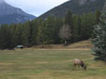 | Alberta Image 117
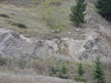 | Alberta Image 118
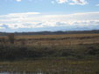 | Alberta Image 119
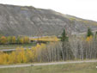 | Alberta Image 120

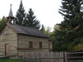 | Alberta Image 121
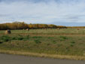 | Alberta Image 122
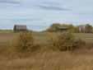 | Alberta Image 123
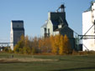 | Alberta Image 124
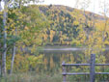 | Alberta Image 125

Used by permission of photographer.

