The Brown Family

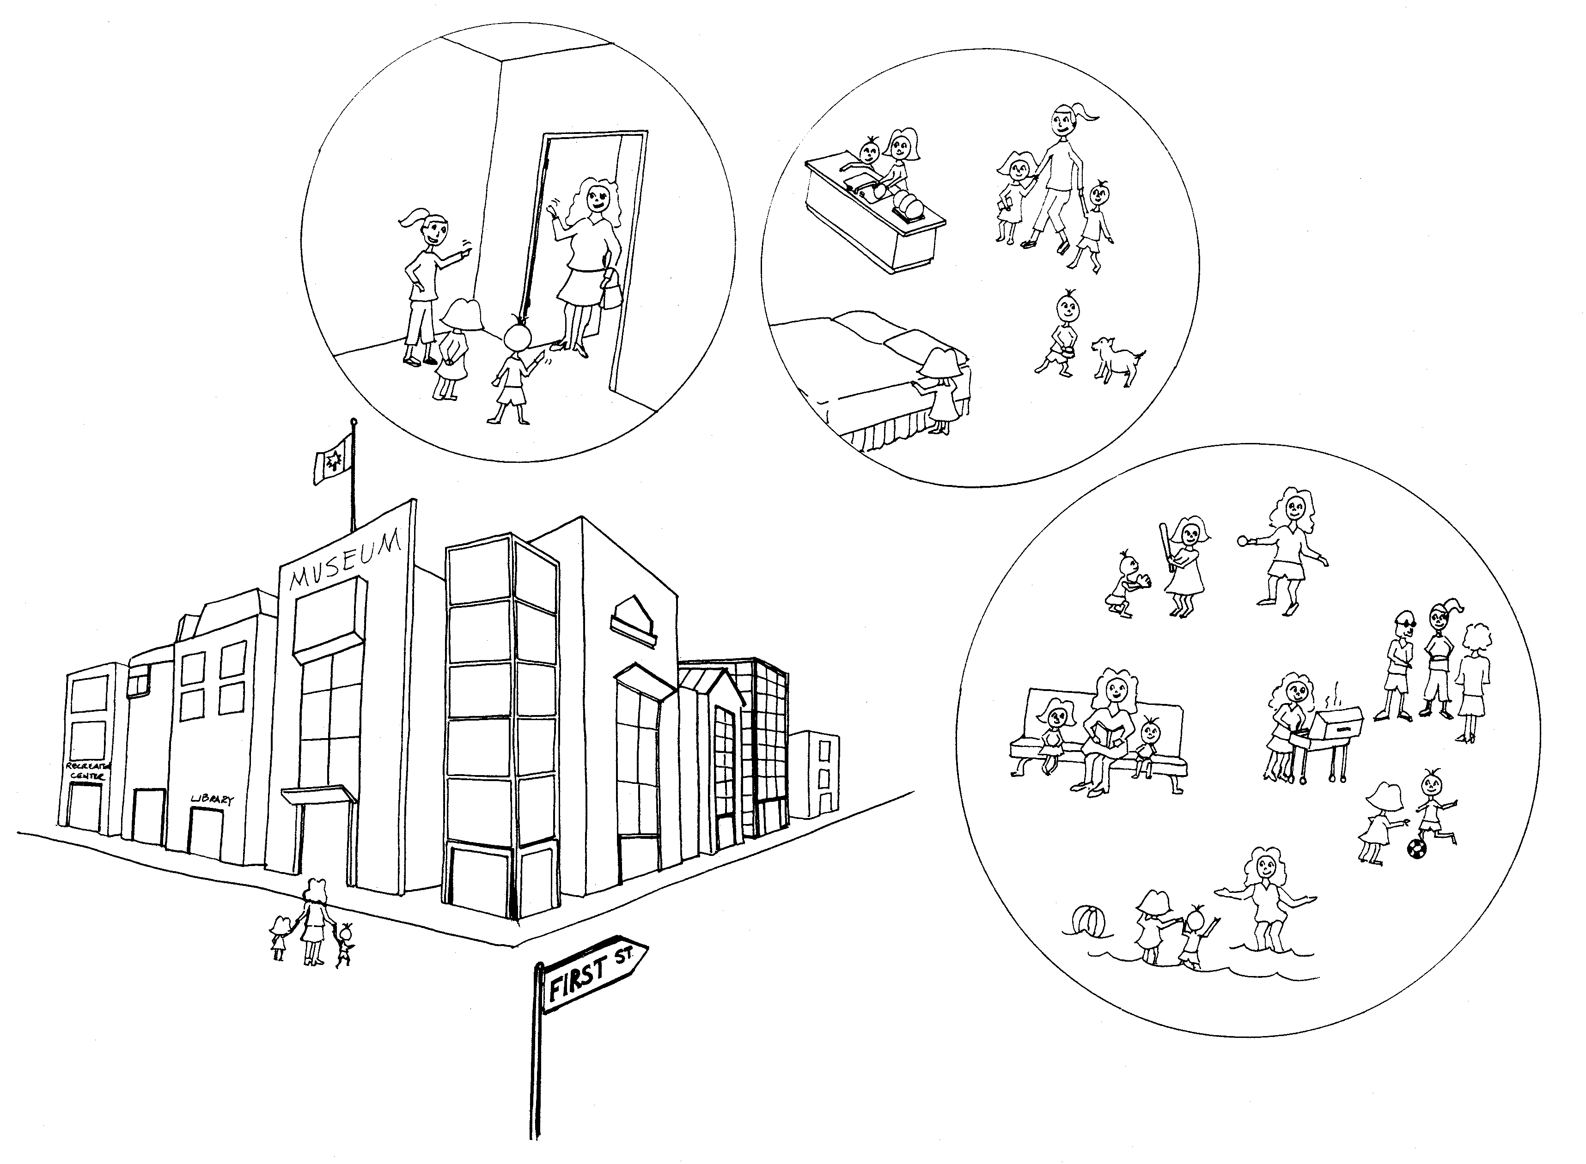

The Brown family lives in an apartment on First Street. Mrs. Brown goes to work to earn money so that she can pay rent for a place to live. Then she can also buy clothes, food, medicine, books, tools and other things her family needs for school and for play. The neighbour looks after the two children after school until Mrs. Brown gets home from work. The children help by feeding the dog, keeping their rooms tidy and drying the dishes. On holidays, Mrs. Brown and her two children play games, tell each other stories and go to the beach, the library, the museum and to baseball and soccer games at the park. The family also likes to swim at the city pool on the weekend. Sometimes the Brown family has a BBQ with their friends.

Adapted from Contributing to Family and Community. Permission granted from The Critical Thinking Consortium for use by Alberta teachers.

