Sorting Memories

I had such a great time at the beach this summer.  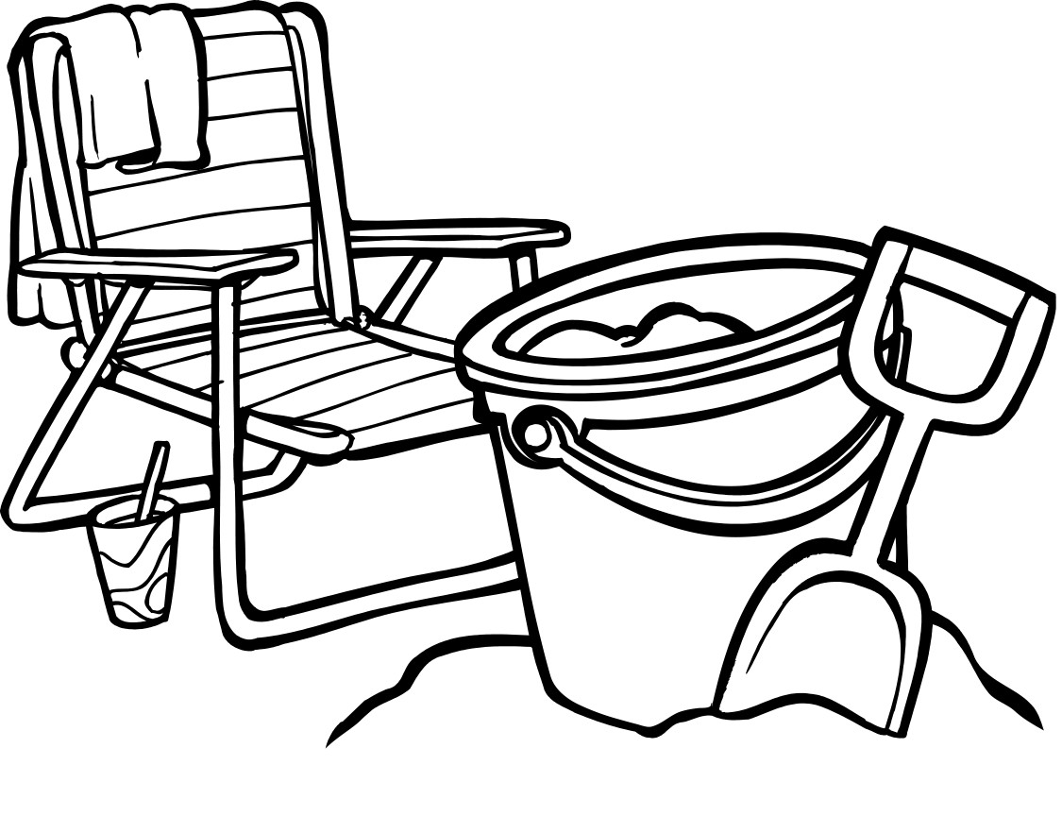 | 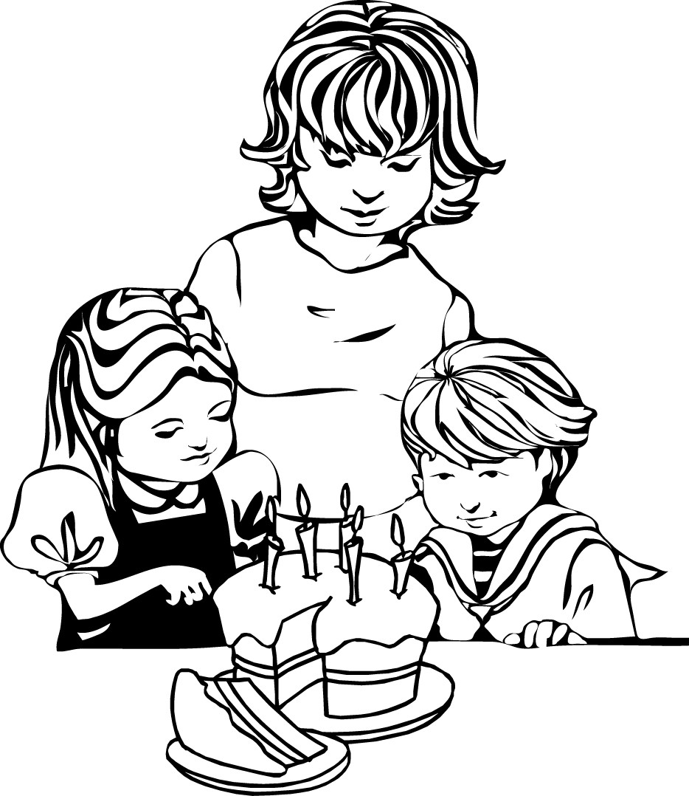  My birthday is next week.
I am sitting on the floor.  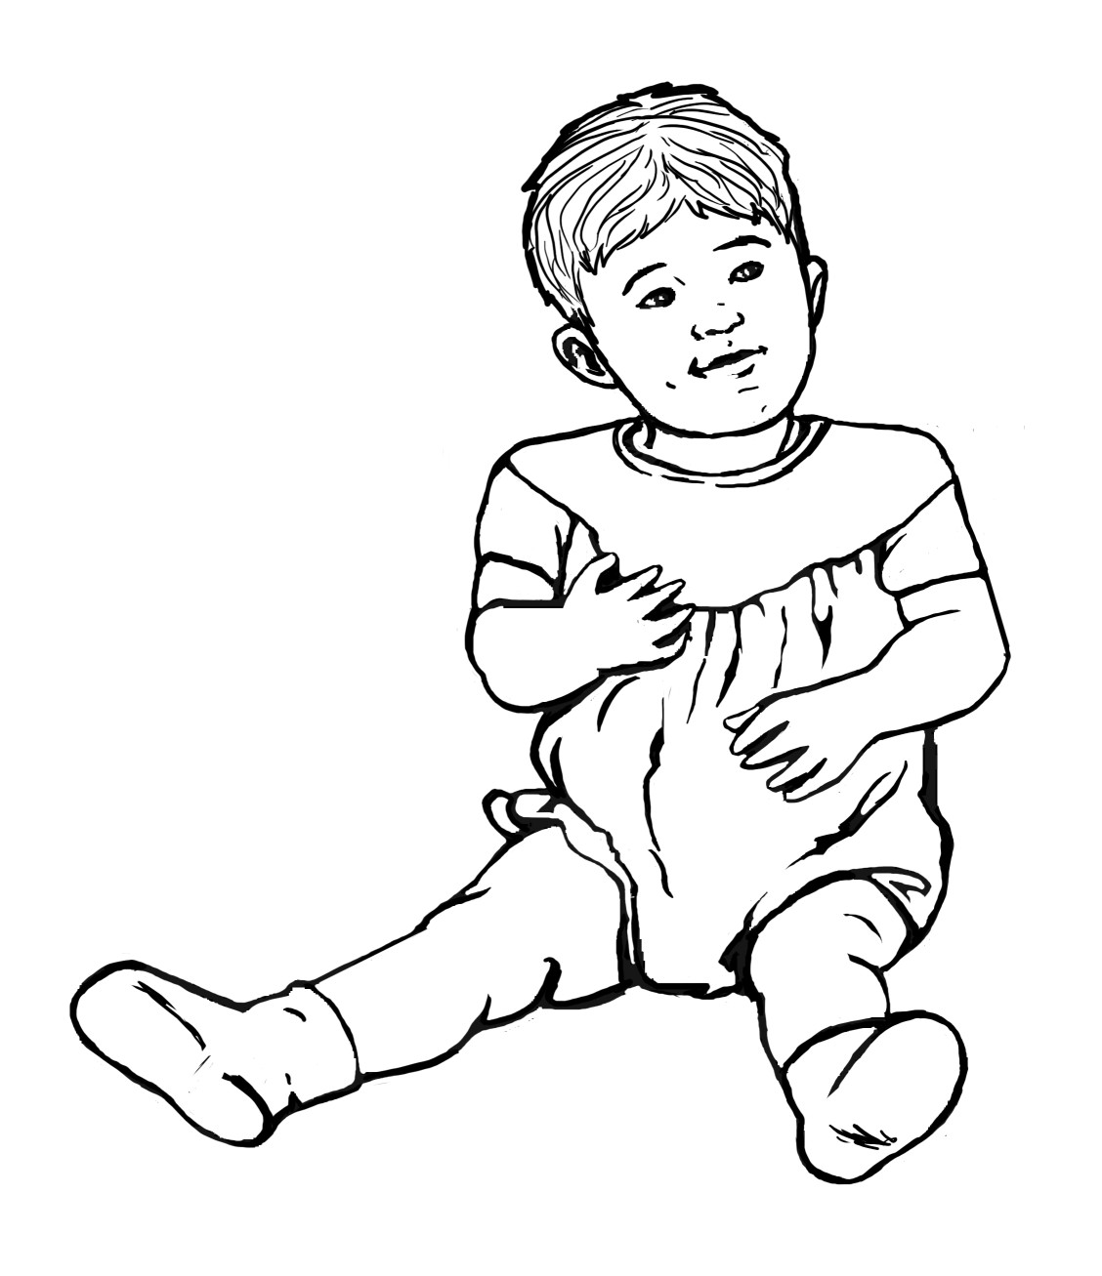 |   When I was little I ate dog food once.
On my friend’s birthday we had lots of fun.  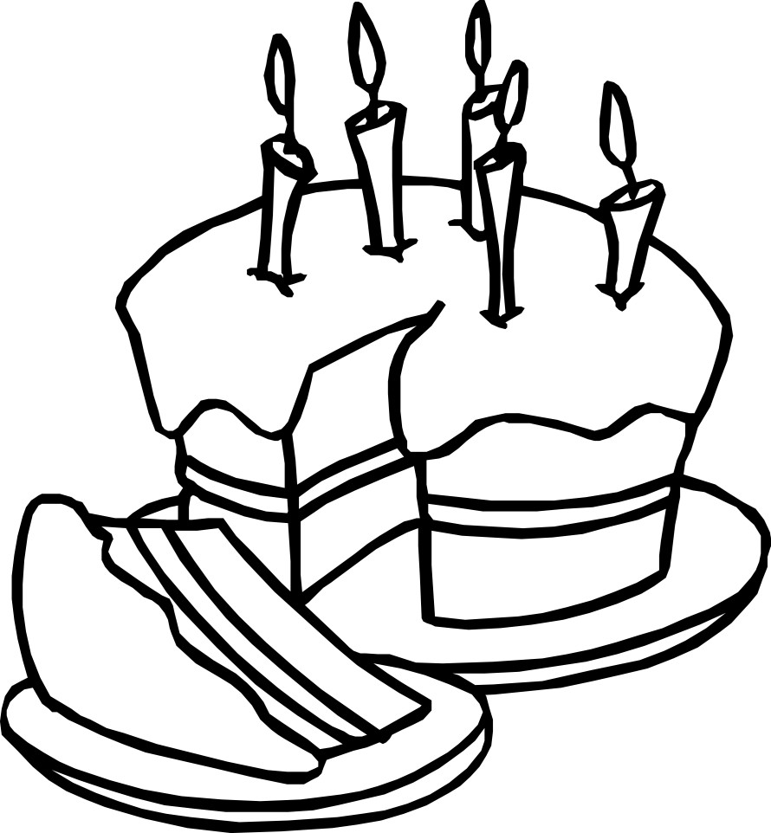 | 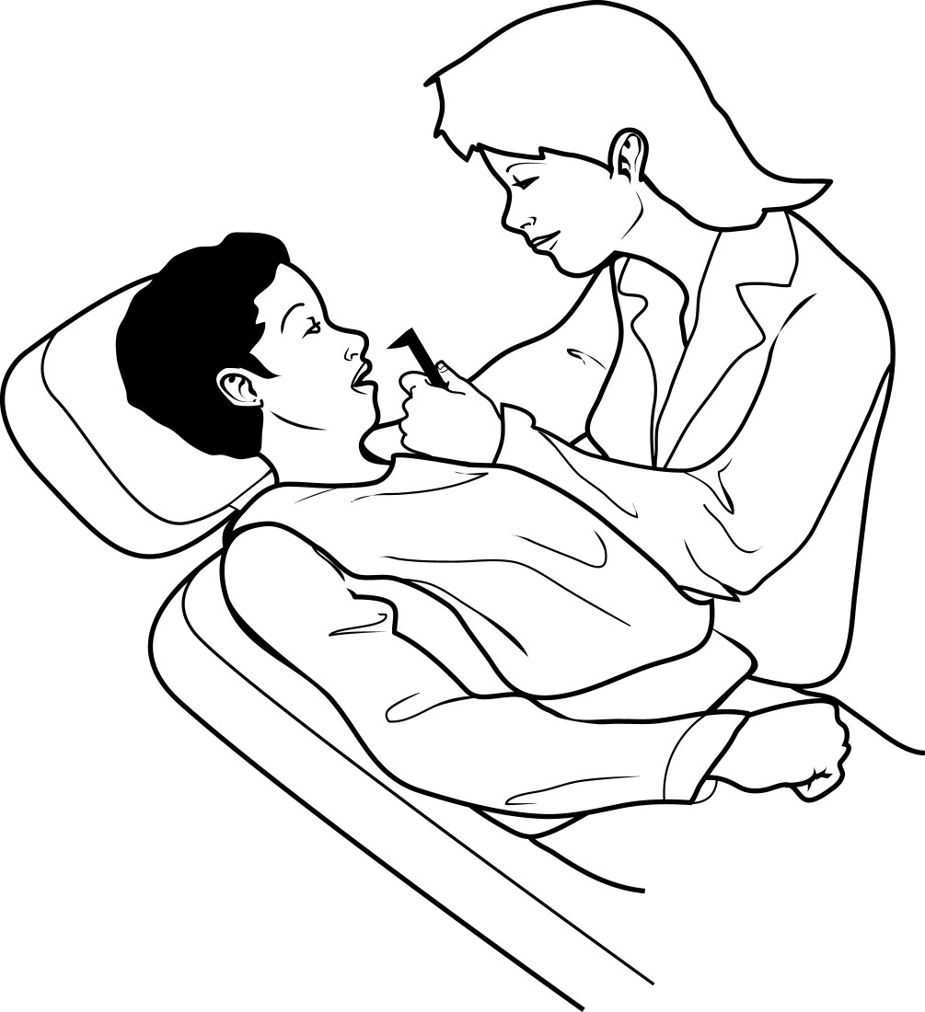  The first time I went I did not like going to the dentist.
I hope it will be sunny tomorrow.  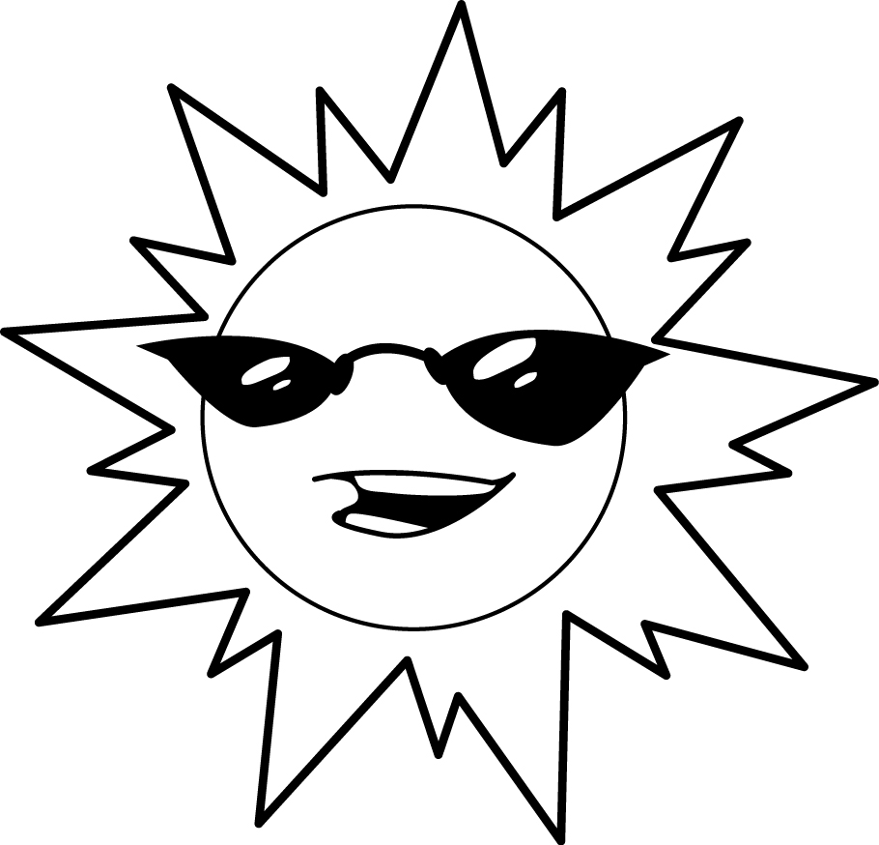 | 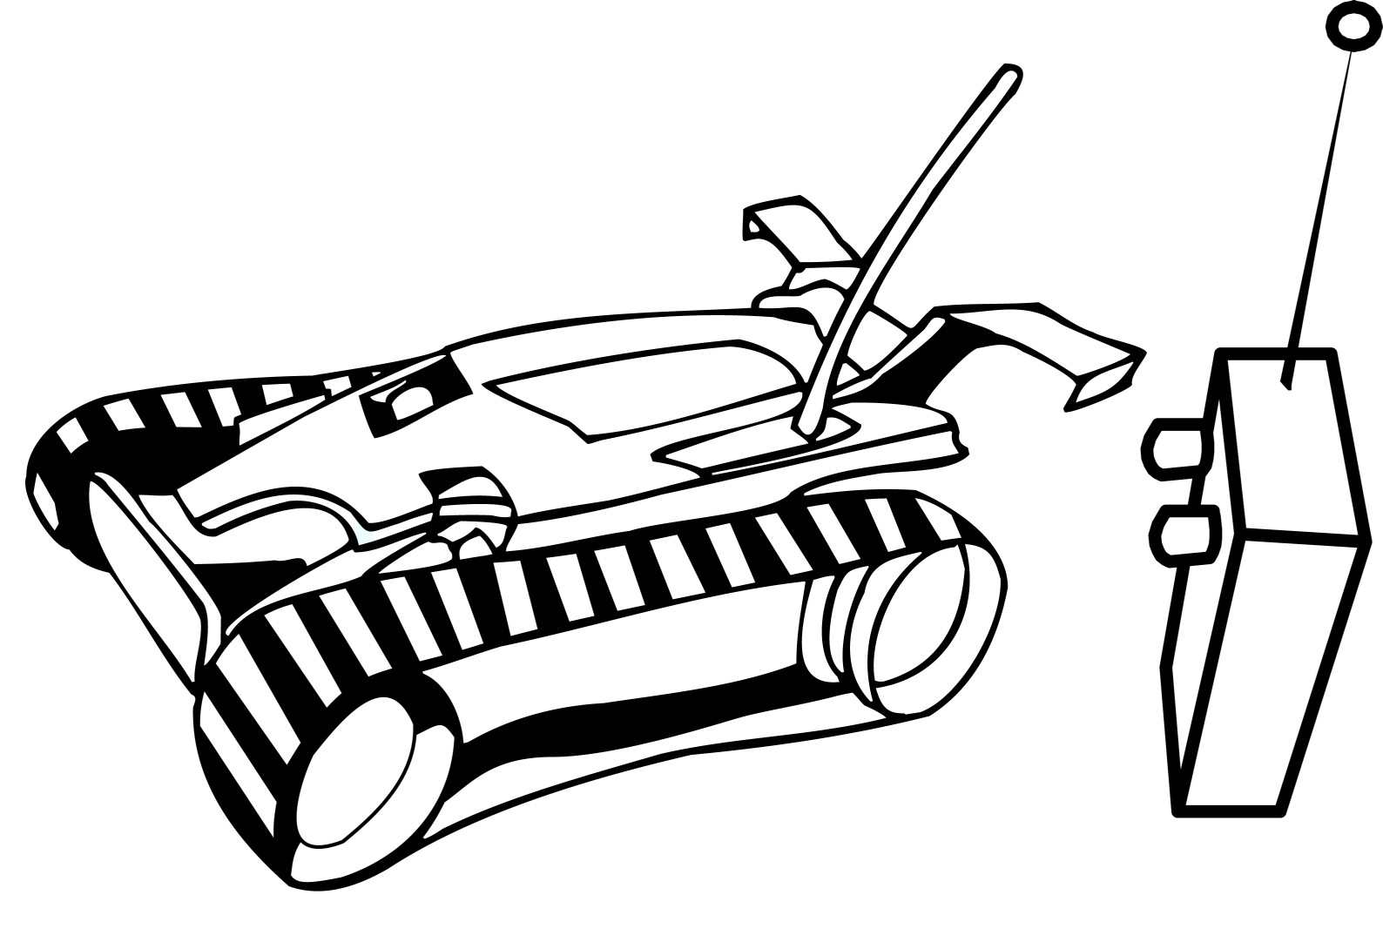  I hope I get a new toy.

Taken from Celebrating Families. Permission granted from The Critical Thinking Consortium for use by Alberta teachers.

