Use this page to track image usage or record descriptions. This document can be adapted for your needs and re-saved.

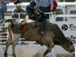 | Alberta: Celebrations and Challenges Image 1
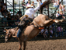 | Alberta: Celebrations and Challenges Image 2
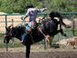 | Alberta: Celebrations and Challenges Image 3
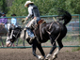 | Alberta: Celebrations and Challenges Image 4
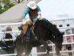 | Alberta: Celebrations and Challenges Image 5
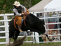 | Alberta: Celebrations and Challenges Image 6
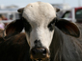 | Alberta: Celebrations and Challenges Image 7
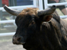 | Alberta: Celebrations and Challenges Image 8
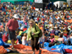 | Alberta: Celebrations and Challenges Image 9

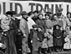 | Alberta: Celebrations and Challenges Image 10
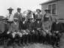 | Alberta: Celebrations and Challenges Image 11
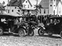 | Alberta: Celebrations and Challenges Image 12
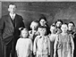 | Alberta: Celebrations and Challenges Image 13
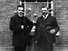 | Alberta: Celebrations and Challenges Image 14
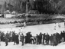 | Alberta: Celebrations and Challenges Image 15
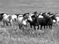 | Alberta: Celebrations and Challenges Image 16
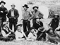 | Alberta: Celebrations and Challenges Image 17
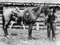 | Alberta: Celebrations and Challenges Image 18
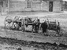 | Alberta: Celebrations and Challenges Image 19
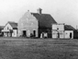 | Alberta: Celebrations and Challenges Image 20
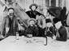 | Alberta: Celebrations and Challenges Image 21
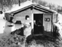 | Alberta: Celebrations and Challenges Image 22
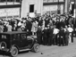 | Alberta: Celebrations and Challenges Image 23
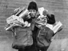 | Alberta: Celebrations and Challenges Image 24
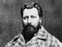 | Alberta: Celebrations and Challenges Image 25
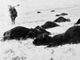 | Alberta: Celebrations and Challenges Image 26
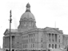 | Alberta: Celebrations and Challenges Image 27
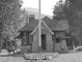 | Alberta: Celebrations and Challenges Image 28
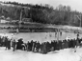 | Alberta: Celebrations and Challenges Image 29

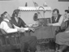 | Alberta: Celebrations and Challenges Image 30
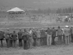 | Alberta: Celebrations and Challenges Image 31
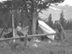 | Alberta: Celebrations and Challenges Image 32
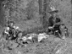 | Alberta: Celebrations and Challenges Image 33
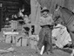 | Alberta: Celebrations and Challenges Image 34
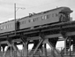 | Alberta: Celebrations and Challenges Image 35
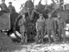 | Alberta: Celebrations and Challenges Image 36
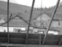 | Alberta: Celebrations and Challenges Image 37
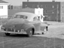 | Alberta: Celebrations and Challenges Image 38
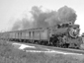 | Alberta: Celebrations and Challenges Image 39
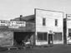 | Alberta: Celebrations and Challenges Image 40
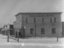 | Alberta: Celebrations and Challenges Image 41
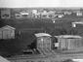 | Alberta: Celebrations and Challenges Image 42
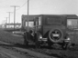 | Alberta: Celebrations and Challenges Image 43
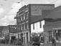 | Alberta: Celebrations and Challenges Image 44
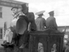 | Alberta: Celebrations and Challenges Image 45
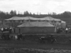 | Alberta: Celebrations and Challenges Image 46
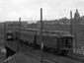 | Alberta: Celebrations and Challenges Image 47
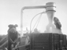 | Alberta: Celebrations and Challenges Image 48
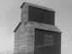 | Alberta: Celebrations and Challenges Image 49

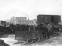 | Alberta: Celebrations and Challenges Image 50
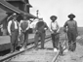 | Alberta: Celebrations and Challenges Image 51
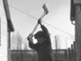 | Alberta: Celebrations and Challenges Image 52
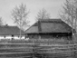 | Alberta: Celebrations and Challenges Image 53
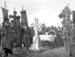 | Alberta: Celebrations and Challenges Image 54
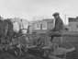 | Alberta: Celebrations and Challenges Image 55
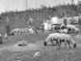 | Alberta: Celebrations and Challenges Image 56
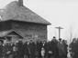 | Alberta: Celebrations and Challenges Image 57
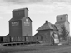 | Alberta: Celebrations and Challenges Image 58
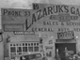 | Alberta: Celebrations and Challenges Image 59
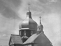 | Alberta: Celebrations and Challenges Image 60
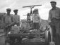 | Alberta: Celebrations and Challenges Image 61
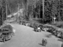 | Alberta: Celebrations and Challenges Image 62
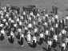 | Alberta: Celebrations and Challenges Image 63
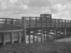 | Alberta: Celebrations and Challenges Image 64
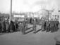 | Alberta: Celebrations and Challenges Image 65
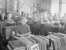 | Alberta: Celebrations and Challenges Image 66
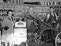 | Alberta: Celebrations and Challenges Image 67
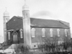 | Alberta: Celebrations and Challenges Image 68
 | Alberta: Celebrations and Challenges Image 69
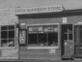 | Alberta: Celebrations and Challenges Image 70
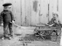 | Alberta: Celebrations and Challenges Image 71
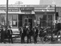 | Alberta: Celebrations and Challenges Image 72
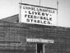 | Alberta: Celebrations and Challenges Image 73
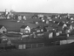 | Alberta: Celebrations and Challenges Image 74
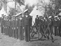 | Alberta: Celebrations and Challenges Image 75
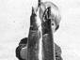 | Alberta: Celebrations and Challenges Image 76
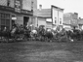 | Alberta: Celebrations and Challenges Image 77
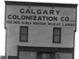 | Alberta: Celebrations and Challenges Image 78
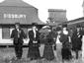 | Alberta: Celebrations and Challenges Image 79
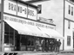 | Alberta: Celebrations and Challenges Image 80
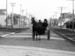 | Alberta: Celebrations and Challenges Image 81
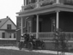 | Alberta: Celebrations and Challenges Image 82
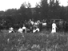 | Alberta: Celebrations and Challenges Image 83
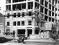 | Alberta: Celebrations and Challenges Image 84
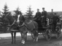 | Alberta: Celebrations and Challenges Image 85
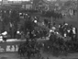 | Alberta: Celebrations and Challenges Image 86
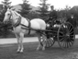 | Alberta: Celebrations and Challenges Image 87
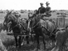 | Alberta: Celebrations and Challenges Image 88
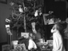 | Alberta: Celebrations and Challenges Image 89
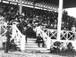 | Alberta: Celebrations and Challenges Image 90
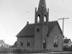 | Alberta: Celebrations and Challenges Image 91
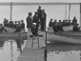 | Alberta: Celebrations and Challenges Image 92
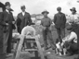 | Alberta: Celebrations and Challenges Image 93
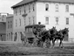 | Alberta: Celebrations and Challenges Image 94
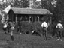 | Alberta: Celebrations and Challenges Image 95
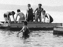 | Alberta: Celebrations and Challenges Image 96
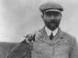 | Alberta: Celebrations and Challenges Image 97
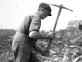 | Alberta: Celebrations and Challenges Image 98
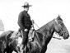 | Alberta: Celebrations and Challenges Image 99
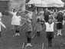 | Alberta: Celebrations and Challenges Image 100
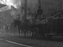 | Alberta: Celebrations and Challenges Image 101
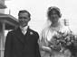 | Alberta: Celebrations and Challenges Image 102
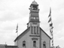 | Alberta: Celebrations and Challenges Image 103
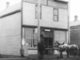 | Alberta: Celebrations and Challenges Image 104
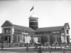 | Alberta: Celebrations and Challenges Image 105
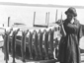 | Alberta: Celebrations and Challenges Image 106
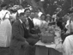 | Alberta: Celebrations and Challenges Image 107
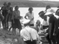 | Alberta: Celebrations and Challenges Image 108
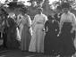 | Alberta: Celebrations and Challenges Image 109
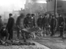 | Alberta: Celebrations and Challenges Image 110
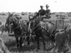 | Alberta: Celebrations and Challenges Image 111
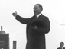 | Alberta: Celebrations and Challenges Image 112
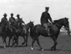 | Alberta: Celebrations and Challenges Image 113
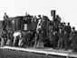 | Alberta: Celebrations and Challenges Image 114
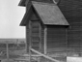 | Alberta: Celebrations and Challenges Image 115
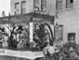 | Alberta: Celebrations and Challenges Image 116
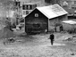 | Alberta: Celebrations and Challenges Image 117
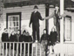 | Alberta: Celebrations and Challenges Image 118
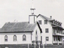 | Alberta: Celebrations and Challenges Image 119
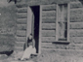 | Alberta: Celebrations and Challenges Image 120
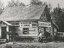 | Alberta: Celebrations and Challenges Image 121
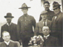 | Alberta: Celebrations and Challenges Image 122
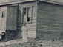 | Alberta: Celebrations and Challenges Image 123
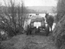 | Alberta: Celebrations and Challenges Image 124
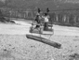 | Alberta: Celebrations and Challenges Image 125
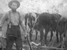 | Alberta: Celebrations and Challenges Image 126
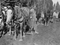 | Alberta: Celebrations and Challenges Image 127
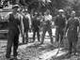 | Alberta: Celebrations and Challenges Image 128
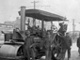 | Alberta: Celebrations and Challenges Image 129
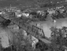 | Alberta: Celebrations and Challenges Image 130
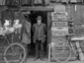 | Alberta: Celebrations and Challenges Image 131
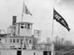 | Alberta: Celebrations and Challenges Image 132
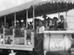 | Alberta: Celebrations and Challenges Image 133
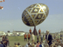 | Alberta: Celebrations and Challenges Image 134
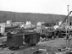 | Alberta: Celebrations and Challenges Image 135
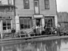 | Alberta: Celebrations and Challenges Image 136
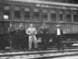 | Alberta: Celebrations and Challenges Image 137
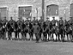 | Alberta: Celebrations and Challenges Image 138
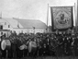 | Alberta: Celebrations and Challenges Image 139
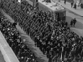 | Alberta: Celebrations and Challenges Image 140

