Use this page to track image usage or record descriptions. This document can be adapted for your needs and re-saved.

 | Being Together Image 1
 | Being Together Image 2
 | Being Together Image 3
 | Being Together Image 4
 | Being Together Image 5
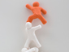 | Being Together Image 6
 | Being Together Image 7
 | Being Together Image 8
 | Being Together Image 9

 | Being Together  Image 10
 | Being Together  Image 11
 | Being Together  Image 12
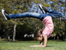 | Being Together  Image 13
 | Being Together  Image 14
 | Being Together  Image 15
 | Being Together  Image 16
 | Being Together  Image 17
 | Being Together  Image 18
 | Being Together  Image 19
 | Being Together  Image 20
 | Being Together  Image 21
 | Being Together  Image 22
 | Being Together  Image 23
 | Being Together  Image 24
 | Being Together  Image 25
 | Being Together  Image 26
 | Being Together  Image 27
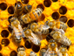 | Being Together  Image 28
 | Being Together  Image 29

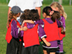 | Being Together  Image 30
 | Being Together  Image 31
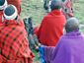 | Being Together  Image 32
 | Being Together  Image 33
 | Being Together  Image 34
 | Being Together  Image 35
 | Being Together  Image 36
 | Being Together  Image 37
 | Being Together  Image 38
 | Being Together  Image 39
 | Being Together  Image 40
 | Being Together  Image 41
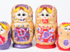 | Being Together  Image 42
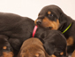 | Being Together  Image 43
 | Being Together  Image 44
 | Being Together  Image 45
 | Being Together  Image 46
 | Being Together  Image 47
 | Being Together  Image 48
 | Being Together  Image 49

 | Being Together Image 50

