Use this page to track image usage or record descriptions. This document can be adapted for your needs and re-saved.

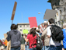 | Democracy Then and Now Image 1
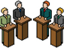 | Democracy Then and Now Image 2
 | Democracy Then and Now Image 3
 | Democracy Then and Now Image 4
 | Democracy Then and Now Image 5
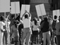 | Democracy Then and Now Image 6
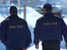 | Democracy Then and Now Image 7
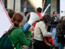 | Democracy Then and Now Image 8
 | Democracy Then and Now Image 9

 | Democracy Then and Now Image 10
 | Democracy Then and Now Image 11
 | Democracy Then and Now Image 12
 | Democracy Then and Now Image 13
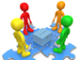 | Democracy Then and Now Image 14
 | Democracy Then and Now Image 15
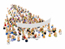 | Democracy Then and Now Image 16
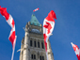 | Democracy Then and Now Image 17
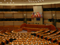 | Democracy Then and Now Image 18
 | Democracy Then and Now Image 19
 | Democracy Then and Now Image 20
 | Democracy Then and Now Image 21
 | Democracy Then and Now Image 22
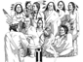 | Democracy Then and Now Image 23
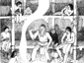 | Democracy Then and Now Image 24
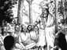 | Democracy Then and Now Image 25
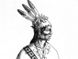 | Democracy Then and Now Image 26
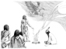 | Democracy Then and Now Image 27
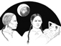 | Democracy Then and Now Image 28
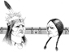 | Democracy Then and Now Image 29

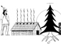 | Democracy Then and Now Image 30
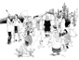 | Democracy Then and Now Image 31
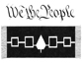 | Democracy Then and Now Image 32
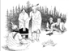 | Democracy Then and Now Image 33
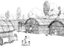 | Democracy Then and Now Image 34
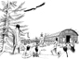 | Democracy Then and Now Image 35
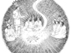 | Democracy Then and Now Image 36
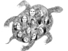 | Democracy Then and Now Image 37
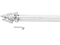 | Democracy Then and Now Image 38
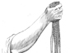 | Democracy Then and Now Image 39
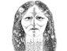 | Democracy Then and Now Image 40
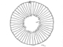 | Democracy Then and Now Image 41
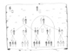 | Democracy Then and Now Image 42
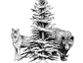 | Democracy Then and Now Image 43
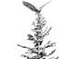 | Democracy Then and Now Image 44
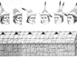 | Democracy Then and Now Image 45
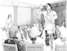 | Democracy Then and Now Image 46
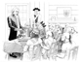 | Democracy Then and Now Image 47
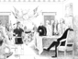 | Democracy Then and Now Image 48
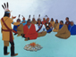 | Democracy Then and Now Image 49

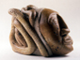 | Democracy Then and Now Image 50
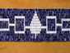 | Democracy Then and Now Image 51
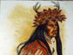 | Democracy Then and Now Image 52
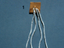 | Democracy Then and Now Image 53
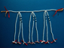 | Democracy Then and Now Image 54
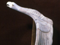 | Democracy Then and Now Image 55

