Use this page to track image usage or record descriptions. This document can be adapted for your needs and re-saved.

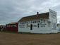 | Ukraine Image 1
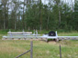 | Ukraine Image 2
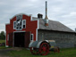 | Ukraine Image 3
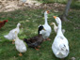 | Ukraine Image 4
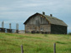 | Ukraine Image 5
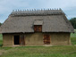 | Ukraine Image 6
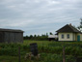 | Ukraine Image 7
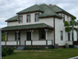 | Ukraine Image 8
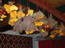 | Ukraine Image 9

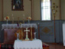 | Ukraine Image 10
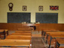 | Ukraine Image 11
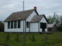 | Ukraine Image 12
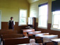 | Ukraine Image 13
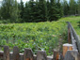 | Ukraine Image 14
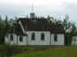 | Ukraine Image 15
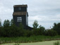 | Ukraine Image 16
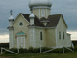 | Ukraine Image 17
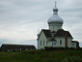 | Ukraine Image 18
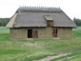 | Ukraine Image 19
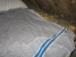 | Ukraine Image 20
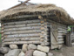 | Ukraine Image 21
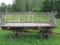 | Ukraine Image 22
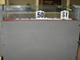 | Ukraine Image 23
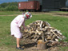 | Ukraine Image 24
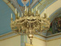 | Ukraine Image 25
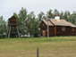 | Ukraine Image 26
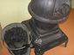 | Ukraine Image 27
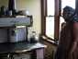 | Ukraine Image 28
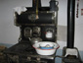 | Ukraine Image 29

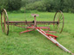 | Ukraine Image 30
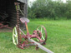 | Ukraine Image 31
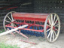 | Ukraine Image 32
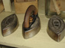 | Ukraine Image 33
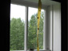 | Ukraine Image 34
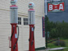 | Ukraine Image 35
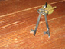 | Ukraine Image 36
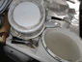 | Ukraine Image 37
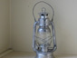 | Ukraine Image 38
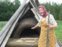 | Ukraine Image 39
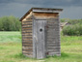 | Ukraine Image 40
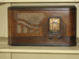 | Ukraine Image 41
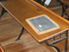 | Ukraine Image 42
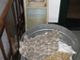 | Ukraine Image 43
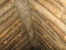 | Ukraine Image 44
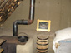 | Ukraine Image 45
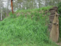 | Ukraine Image 46
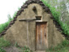 | Ukraine Image 47
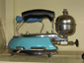 | Ukraine Image 48
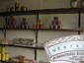 | Ukraine Image 49

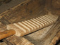 | Ukraine Image 50
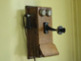 | Ukraine Image 51
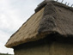 | Ukraine Image 52
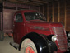 | Ukraine Image 53
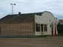 | Ukraine Image 54

