Use this page to track image usage or record descriptions. This document can be adapted for your needs and re-saved.

 | Worldviews Image 1
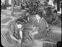 | Worldviews Image 2
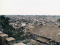 | Worldviews Image 3
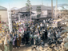 | Worldviews Image 4
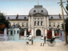 | Worldviews Image 5
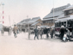 | Worldviews Image 6
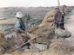 | Worldviews Image 7
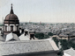 | Worldviews Image 8
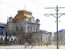 | Worldviews Image 9

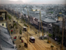 | Worldviews Image 10
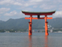 | Worldviews Image 11
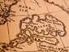 | Worldviews Image 12
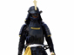 | Worldviews Image 13
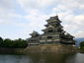 | Worldviews Image 14
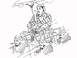 | Worldviews Image 15
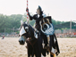 | Worldviews Image 16
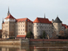 | Worldviews Image 17
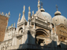 | Worldviews Image 18
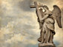 | Worldviews Image 19
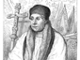 | Worldviews Image 20
 | Worldviews Image 21
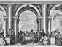 | Worldviews Image 22
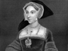 | Worldviews Image 23
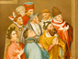 | Worldviews Image 24
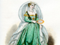 | Worldviews Image 25
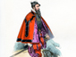 | Worldviews Image 26
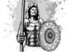 | Worldviews Image 27
 | Worldviews Image 28
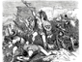 | Worldviews Image 29

 | Worldviews Image 30
 | Worldviews Image 31
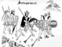 | Worldviews Image 32
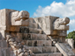 | Worldviews Image 33
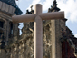 | Worldviews Image 34
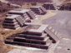 | Worldviews Image 35
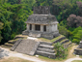 | Worldviews Image 36
 | Worldviews Image 37
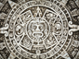 | Worldviews Image 38
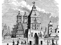 | Worldviews Image 39
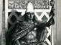 | Worldviews Image 40

