Use this page to track image usage or record descriptions. This document can be adapted for your needs and re-saved.

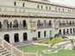 | India Image 1  Jaipur, Rajasthan
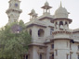 | India Image 2  Mayo Boys School
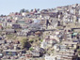 | India Image 3  Shimla
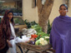 | India Image 4  Delhi
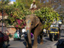 | India Image 5  Udaipur, Rajasthan
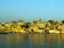 | India Image 6  Udaipur, Rajasthan
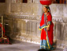 | India Image 7  Udaipur, Rajasthan
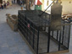 | India Image 8  Udaipur, Rajasthan
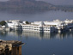 | India Image 9  Udaipur, Rajasthan

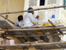 | India Image 10  Udaipur, Rajasthan
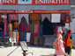 | India Image 11  Udaipur, Rajasthan
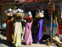 | India Image 12  Udaipur, Rajasthan
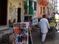 | India Image 13  Udaipur, Rajasthan
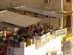 | India Image 14  Udaipur, Rajasthan
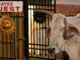 | India Image 15  Udaipur, Rajasthan
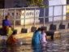 | India Image 16  Udaipur, Rajasthan
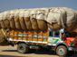 | India Image 17  Rajasthan
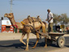 | India Image 18  Rajasthan
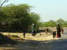 | India Image 19  Rajasthan
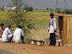 | India Image 20  Rajasthan
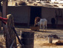 | India Image 21  Rajasthan
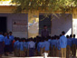 | India Image 22  Rajasthan
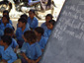 | India Image 23  Rajasthan
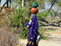 | India Image 24  Rajasthan
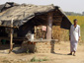 | India Image 25  Rajasthan
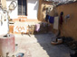 | India Image 26  Rajasthan
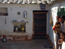 | India Image 27  Rajasthan
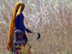 | India Image 28  Rajasthan
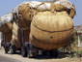 | India Image 29  Rajasthan

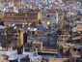 | India Image 30  Bundi, Rajasthan
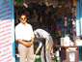 | India Image 31  Bundi, Rajasthan
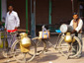 | India Image 32
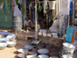 | India Image 33  Bundi, Rajasthan
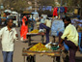 | India Image 34  Bundi, Rajasthan
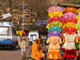 | India Image 35  Bundi, Rajasthan
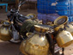 | India Image 36  Bundi, Rajasthan
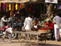 | India Image 37  Bundi, Rajasthan
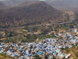 | India Image 38  Bundi, Rajasthan
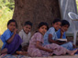 | India Image 39  Bundi, Rajasthan
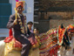 | India Image 40  Thikarda, Rajasthan
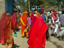 | India Image 41  Thikarda, Rajasthan
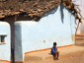 | India Image 42  Thikarda, Rajasthan
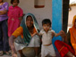 | India Image 43  Thikarda, Rajasthan
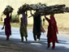 | India Image 44  Bundi, Rajasthan
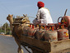 | India Image 45  Rajasthan
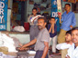 | India Image 46  Bundi, Rajasthan
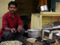 | India Image 47  Bundi, Rajasthan
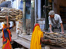 | India Image 48  Bundi, Rajasthan
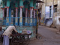 | India Image 49  Bundi, Rajasthan

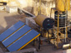 | India Image 50  Bundi, Rajasthan
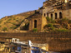 | India Image 51  Bundi, Rajasthan
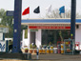 | India Image 52  Rajasthan
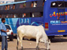 | India Image 53  Rajasthan
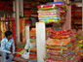 | India Image 54  Jaipur, Rajasthan
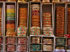 | India Image 55  Jaipur, Rajasthan
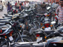 | India Image 56  Jaipur, Rajasthan
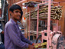 | India Image 57  Delhi
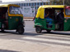 | India Image 58  Delhi
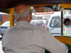 | India Image 59  Delhi
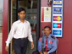 | India Image 60  Delhi
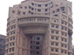 | India Image 61  Delhi
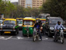 | India Image 62  Delhi
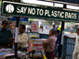 | India Image 63  Delhi
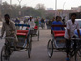 | India Image 64  Delhi
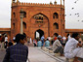 | India Image 65  Jama Masjid, Delhi
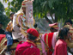 | India Image 66  Chandigarh
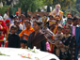 | India Image 67  Chandigarh
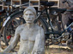 | India Image 68  Chandigarh
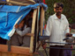 | India Image 69  Chandigarh

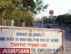 | India Image 70  Chandigarh
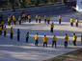 | India Image 71  Chandigarh
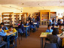 | India Image 72  Chandigarh
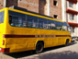 | India Image 73  Chandigarh: Vivek High School
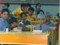 | India Image 74  Chandigarh: Vivek High School
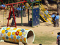 | India Image 75  Chandigarh: Vivek High School
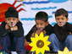 | India Image 76  Chandigarh: Vivek High School
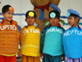 | India Image 77  Chandigarh: Vivek High School
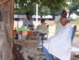 | India Image 78  Chandigarh
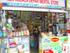 | India Image 79  Chandigarh
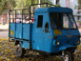 | India Image 80  Bundi, Rajasthan
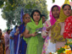 | India Image 81  Chandigarh
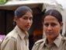 | India Image 82  Chandigarh
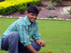 | India Image 83  Chandigarh
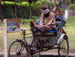 | India Image 84  Chandigarh
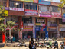 | India Image 85  Chandigarh
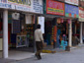 | India Image 86  Chandigarh
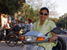 | India Image 87
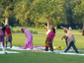 | India Image 88  Chandigarh
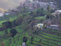 | India Image 89  Kasauli

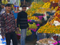 | India Image 90  Dehra Dun, Uttaranchal
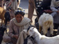 | India Image 91  Dehra Dun, Uttaranchal
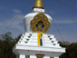 | India Image 92  Dehra Dun, Uttaranchal
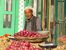 | India Image 93  Dehra Dun, Uttaranchal
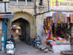 | India Image 94  Dehra Dun, Uttaranchal
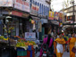 | India Image 95  Dehra Dun, Uttaranchal
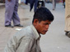 | India Image 96  Dehra Dun, Uttaranchal
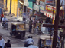 | India Image 97  Dehra Dun, Uttaranchal
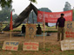 | India Image 98  Chandigarh: Vivek High School
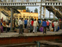 | India Image 99  Chandigarh
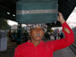 | India Image 100  Chandigarh
The images above have been reproduced with permission from Susan Duncan.
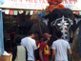 | India Image 101  Goa
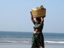 | India Image 102  Goa
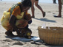 | India Image 103  Goa
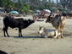 | India Image 104  Goa
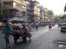 | India Image 105  Mumbai
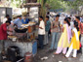 | India Image 106  Mumbai
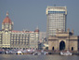 | India Image 107  Mumbai
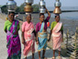 | India Image 108  Mumbai
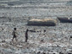 | India Image 109  Mumbai
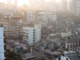 | India Image 110  Mumbai
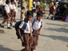 | India Image 111  Mysore
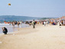 | India Image 112  Goa
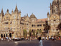 | India Image 113  Mumbai
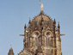 | India Image 114  Mumbai
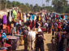 | India Image 115  Goa
The images above have been reproduced with permission from Darren Shaw.

Image Collection photographs may be used freely in any non-profit educational context provided a credit to the source is included in your work. Any other use requires written permission from the copyright holder. Third-party images are identified by a credit to the copyright holder.

