Use this page to track image usage or record descriptions. This document can be adapted for your needs and re-saved.
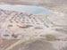 | Nunavut Image 1  Gjoa Haven
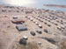 | Nunavut Image 2  Gjoa Haven
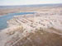 | Nunavut Image 3  Gjoa Haven
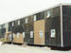 | Nunavut Image 4  Gjoa Haven
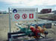 | Nunavut Image 5  Gjoa Haven
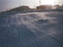 | Nunavut Image 6  Gjoa Haven
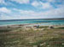 | Nunavut Image 7  Gjoa Haven
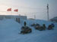 | Nunavut Image 8  Gjoa Haven

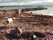 | Nunavut Image 9  Gjoa Haven
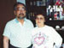 | Nunavut Image 10  Gjoa Haven
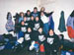 | Nunavut Image 11  Gjoa Haven
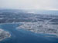 | Nunavut Image 12  Gjoa Haven
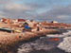 | Nunavut Image 13  Gjoa Haven
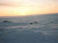 | Nunavut Image 14  Gjoa Haven
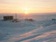 | Nunavut Image 15  Gjoa Haven
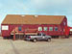 | Nunavut Image 16  Gjoa Haven

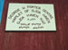 | Nunavut Image 17  Gjoa Haven
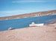 | Nunavut Image 18  Gjoa Haven
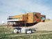 | Nunavut Image 19  Gjoa Haven
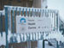 | Nunavut Image 20  Gjoa Haven
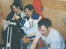 | Nunavut Image 21  Gjoa Haven
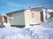 | Nunavut Image 22  Gjoa Haven
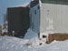 | Nunavut Image 23  Gjoa Haven
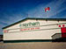 | Nunavut Image 24  Gjoa Haven

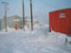 | Nunavut Image 25  Gjoa Haven
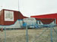 | Nunavut Image 26  Quqshuun Illihakvik School
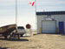 | Nunavut Image 27  Gjoa Haven
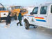 | Nunavut Image 28  Gjoa Haven
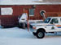 | Nunavut Image 29  Gjoa Haven
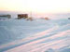 | Nunavut Image 30  Gjoa Haven
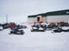 | Nunavut Image 31  Gjoa Haven
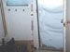 | Nunavut Image 32  Gjoa Haven

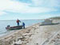 | Nunavut Image 33  Gjoa Haven
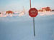 | Nunavut Image 34  Gjoa Haven
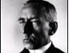 | Nunavut Image 35  Roald Amundsen
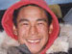 | Nunavut Image 36  Judas Karoo
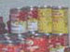 | Nunavut Image 37
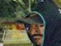 | Nunavut Image 38
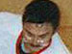 | Nunavut Image 39
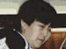 | Nunavut Image 40

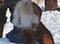 | Nunavut Image 41
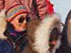 | Nunavut Image 42
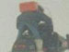 | Nunavut Image 43
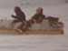 | Nunavut Image 44
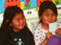 | Nunavut Image 45
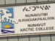 | Nunavut Image 46
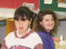 | Nunavut Image 47
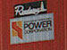 | Nunavut Image 48

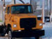 | Nunavut Image 49
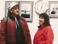 | Nunavut Image 50
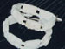 | Nunavut Image 51
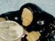 | Nunavut Image 52
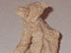 | Nunavut Image 53
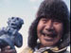 | Nunavut Image 54
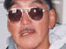 | Nunavut Image 55
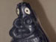 | Nunavut Image 56

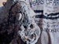 | Nunavut Image 57
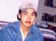 | Nunavut Image 58
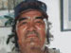 | Nunavut Image 59
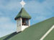 | Nunavut Image 60
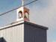 | Nunavut Image 61
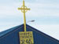 | Nunavut Image 62
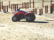 | Nunavut Image 63

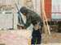 | Nunavut Image 64
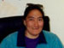 | Nunavut Image 65
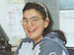 | Nunavut Image 66
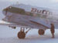 | Nunavut Image 67
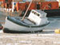 | Nunavut Image 68
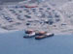 | Nunavut Image 69
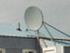 | Nunavut Image 70
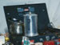 | Nunavut Image 71

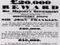 | Nunavut Image 72
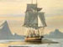 | Nunavut Image 73
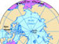 | Nunavut Image 74
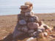 | Nunavut Image 75
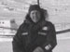 | Nunavut Image 76  Charlie Cahill
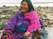 | Nunavut Image 77
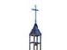 | Nunavut Image 78
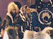 | Nunavut Image 79

 | Nunavut Image 80
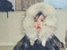 | Nunavut Image 81
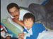 | Nunavut Image 82
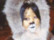 | Nunavut Image 83
 | Nunavut Image 84
Reproduced with permission from Central Arctic Ltd., Nunavut Territory, Canada, CD-ROM (Edmonton, AB: Central Arctic Ltd., 2001).
Image Collection photographs may be used freely in any non-profit educational context provided a credit to the source is included in your work. Any other use requires written permission from the copyright holder. Third-party images are identified by a credit to the copyright holder.

