Use this page to track image usage or record descriptions. This document can be adapted for your needs and re-saved.

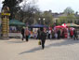 | Ukraine Image 1  Ivano-Frankivsk
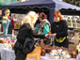 | Ukraine Image 2  Ivano-Frankivsk
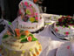 | Ukraine Image 3  Ivano-Frankivsk
 | Ukraine Image 4  Ivano-Frankivsk
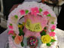 | Ukraine Image 5  Ivano-Frankivsk
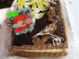 | Ukraine Image 6  Ivano-Frankivsk
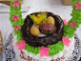 | Ukraine Image 7  Ivano-Frankivsk
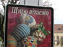 | Ukraine Image 8  Ivano-Frankivsk
 | Ukraine Image 9  Ivano-Frankivsk

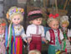 | Ukraine Image 10  Ivano-Frankivsk
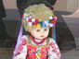 | Ukraine Image 11  Ivano-Frankivsk
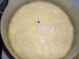 | Ukraine Image 12  Ivano-Frankivsk
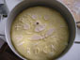 | Ukraine Image 13  Ivano-Frankivsk
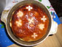 | Ukraine Image 14  Ivano-Frankivsk
 | Ukraine Image 15  Ivano-Frankivsk
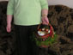 | Ukraine Image 16  Ivano-Frankivsk
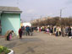 | Ukraine Image 17  Ivano-Frankivsk
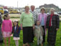 | Ukraine Image 18  Ivano-Frankivsk
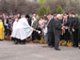 | Ukraine Image 19  Ivano-Frankivsk
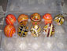 | Ukraine Image 20  Ivano-Frankivsk
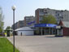 | Ukraine Image 21  Ivano-Frankivsk
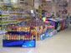 | Ukraine Image 22  Ivano-Frankivsk
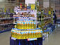 | Ukraine Image 23  Ivano-Frankivsk
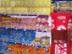 | Ukraine Image 24  Ivano-Frankivsk
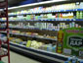 | Ukraine Image 25  Ivano-Frankivsk
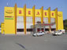 | Ukraine Image 26  Ivano-Frankivsk
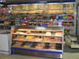 | Ukraine Image 27  Ivano-Frankivsk
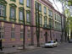 | Ukraine Image 28  Ivano-Frankivsk
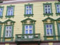 | Ukraine Image 29  Ivano-Frankivsk

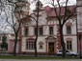 | Ukraine Image 30  Ivano-Frankivsk
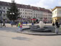 | Ukraine Image 31  Ivano-Frankivsk
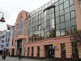 | Ukraine Image 32  Ivano-Frankivsk
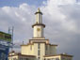 | Ukraine Image 33  Ivano-Frankivsk
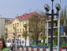 | Ukraine Image 34  Ivano-Frankivsk
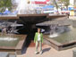 | Ukraine Image 35  Ivano-Frankivsk
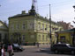 | Ukraine Image 36  Ivano-Frankivsk
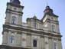 | Ukraine Image 37  Ivano-Frankivsk
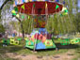 | Ukraine Image 38  Ivano-Frankivsk
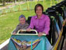 | Ukraine Image 39  Ivano-Frankivsk
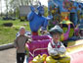 | Ukraine Image 40  Ivano-Frankivsk
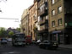 | Ukraine Image 41  Ivano-Frankivsk
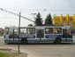 | Ukraine Image 42  Ivano-Frankivsk
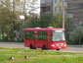 | Ukraine Image 43  Ivano-Frankivsk
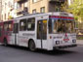 | Ukraine Image 44  Ivano-Frankivsk
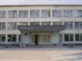 | Ukraine Image 45  Ivano-Frankivsk
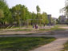 | Ukraine Image 46  Ivano-Frankivsk
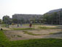 | Ukraine Image 47  Ivano-Frankivsk
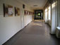 | Ukraine Image 48  Ivano-Frankivsk
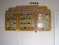 | Ukraine Image 49  Ivano-Frankivsk

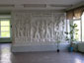 | Ukraine Image 50  Ivano-Frankivsk
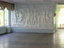 | Ukraine Image 51  Ivano-Frankivsk
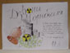 | Ukraine Image 52  Ivano-Frankivsk
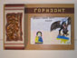 | Ukraine Image 53  Ivano-Frankivsk
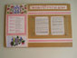 | Ukraine Image 54  Ivano-Frankivsk
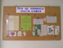 | Ukraine Image 55  Ivano-Frankivsk
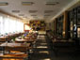 | Ukraine Image 56  Ivano-Frankivsk
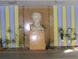 | Ukraine Image 57  Ivano-Frankivsk
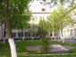 | Ukraine Image 58  Ivano-Frankivsk
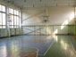 | Ukraine Image 59  Ivano-Frankivsk
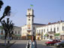 | Ukraine Image 60  Kolomuya
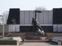 | Ukraine Image 61  Kolomuya
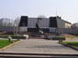 | Ukraine Image 62  Kolomuya
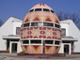 | Ukraine Image 63  Kolomuya
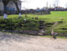 | Ukraine Image 64  Ostapkivtsi
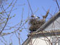 | Ukraine Image 65  Ostapkivtsi
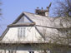 | Ukraine Image 66  Ostapkivtsi
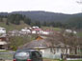 | Ukraine Image 67  Verchovuna
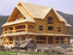 | Ukraine Image 68  Verchovuna
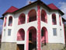 | Ukraine Image 69  Verchovuna

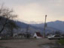 | Ukraine Image 70  Verchovuna
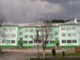 | Ukraine Image 71  Verchovuna
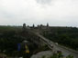 | Ukraine Image 72  Kamyanets-Podilsky
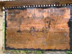 | Ukraine Image 73  Kamyanets-Podilsky
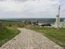 | Ukraine Image 74  Khotyn
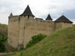 | Ukraine Image 75  Khotyn
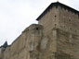 | Ukraine Image 76  Khotyn
The images above have been used by permission from the photographer.

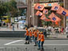 | Ukraine Image 77
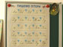 | Ukraine Image 78

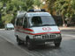 | Ukraine Image 79
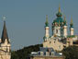 | Ukraine Image 80  Andriyivska Church, Kyiv
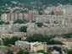 | Ukraine Image 81
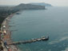 | Ukraine Image 82  Black Sea
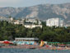 | Ukraine Image 83  Crimea
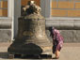 | Ukraine Image 84  Pechersk Lavra, Kyiv
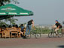 | Ukraine Image 85
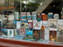 | Ukraine Image 86
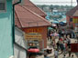 | Ukraine Image 87  Chernivtski

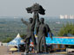 | Ukraine Image 88
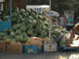 | Ukraine Image 89  Crimea
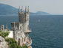 | Ukraine Image 90  Swallow’s Nest Castle, Crimea
 | Ukraine Image 91
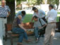 | Ukraine Image 92
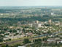 | Ukraine Image 93
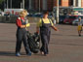 | Ukraine Image 94
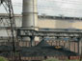 | Ukraine Image 95  Dnipropetrovsk
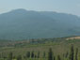 | Ukraine Image 96

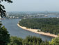 | Ukraine Image 97  Kyiv
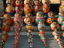 | Ukraine Image 98
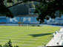 | Ukraine Image 99  Lobanovsky Dynamo Stadium, Kyiv
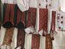 | Ukraine Image 100
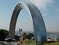 | Ukraine Image 101  Kyiv
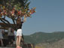 | Ukraine Image 102
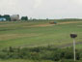 | Ukraine Image 103
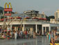 | Ukraine Image 104  Crimea
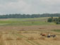 | Ukraine Image 105

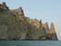 | Ukraine Image 106  Kara-dah Nature Reserve
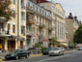 | Ukraine Image 107  Kyiv
 | Ukraine Image 108
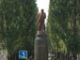 | Ukraine Image 109
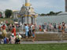 | Ukraine Image 110
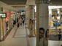 | Ukraine Image 111  Kyiv
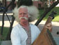 | Ukraine Image 112
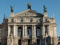 | Ukraine Image 113  Ivan Franko Opera House, Lviv
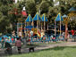 | Ukraine Image 114

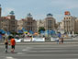 | Ukraine Image 115  Kyiv
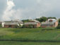 | Ukraine Image 116
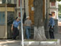 | Ukraine Image 117
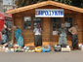 | Ukraine Image 118  Chernivtski
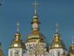 | Ukraine Image 119  St. Michael’s Monastery, Kyiv
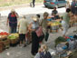 | Ukraine Image 120  Lviv
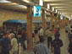 | Ukraine Image 121  Kyiv
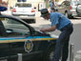 | Ukraine Image 122  Kyiv
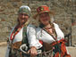 | Ukraine Image 123

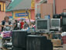 | Ukraine Image 124  Chernivtski
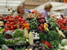 | Ukraine Image 125  Kyiv
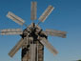 | Ukraine Image 126
The images above have been reproduced with permission from Diversity Works.
Image Collection photographs may be used freely in any non-profit educational context provided a credit to the source is included in your work. Any other use requires written permission from the copyright holder. Third-party images are identified by a credit to the copyright holder.

